PROJECT REPORT

CLASSIC LOAD BALANCER ON AWS CONSOLE

GROUP 2 – dEEPAK, nATHANIEL, jAHNAVI, mATTHEW, eFANGA

2021

**OVERVIEW**

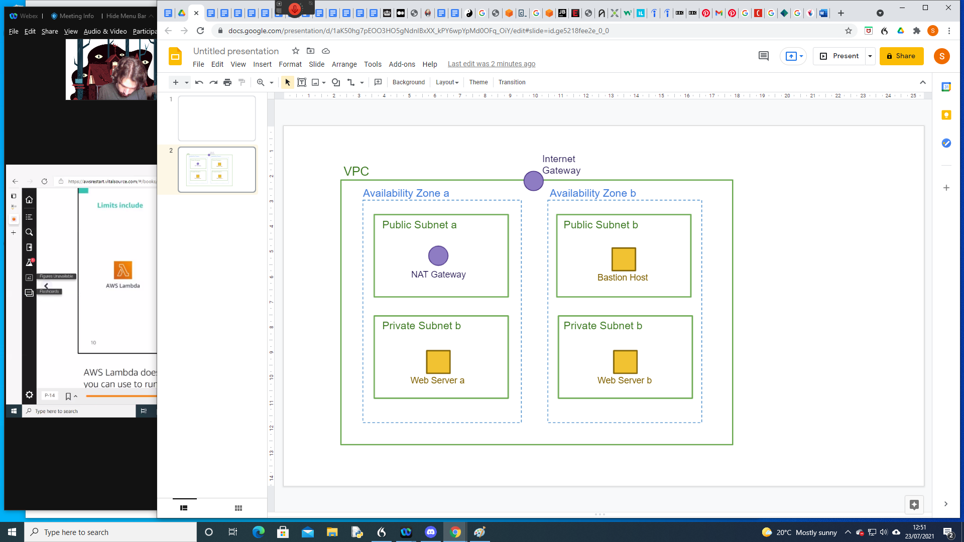

1. create a VPC

group-two-vpc

10.0.0.0/16

1. 4 subnets, two private, two public

private-subnet-a

10.0.0.0/24

availability zone a

private-subnet-b

10.0.1.0/24

availability zone b

auto-assign elastic ipv4

public-subnet-a

10.0.2.0/24

availability zone a

public-subnet-b

10.0.3.0/24

availability zone b

3. Internet gateway

group2-igw

4. NAT gateway

group2-nat-gw

public-subnet-a

5. Routes table

private-route-table (main=yes)

associations:

private-subnet-a

private-subnet-b

0.0.0.0/0 nat gateway

public-route-table

associations:

public-subnet-a

public-subnet-b

0.0.0.0/0 igw

6. EC2

Webserver 1

amazon linux 2

t2.micro

group-2-vpc

private-subnet-b

enable auto-assign ip

userdata as text:

**#!/bin/bash**

**sudo su**

**yum update -y**

**yum install httpd -y**

**cd /var/www/html**

**echo "<html><h1>THIS IS SERVER-01</h1></html>" > index.html**

**systemctl start httpd**

**chkconfig httpd on**

tag:

Name

Webserver-b

security group:

Webserver-a

HTTP all addresses

HTTPS all addresses

create new Key pair

webserver-b

7. Webserver 2

amazon linux 2

t2.micro

group-2-vpc

private-subnet-a

enable auto-assign ip

userdata as text:

**#!/bin/bash**

**sudo su**

**yum update -y**

**yum install httpd -y**

**cd /var/www/html**

**echo "<html><h1>THIS IS SERVER-02</h1></html>" > index.html**

**systemctl start httpd**

**chkconfig httpd on**

tag:

Name

webserver-b

security group:

name: WebServer-a

HTTP all addresses

HTTPS all addresses

create new Key pair

webserver-a

8. classic load balancer

Group2-loadbalancer

protocols:

HTTP

security groups:

Webserver-a

configure health check:

response timeouts 3

interval 10

unhealthy threshold 2

healthy threshold 5

**SCREEN SHOTS**

**Creating VPC in AWS management console**

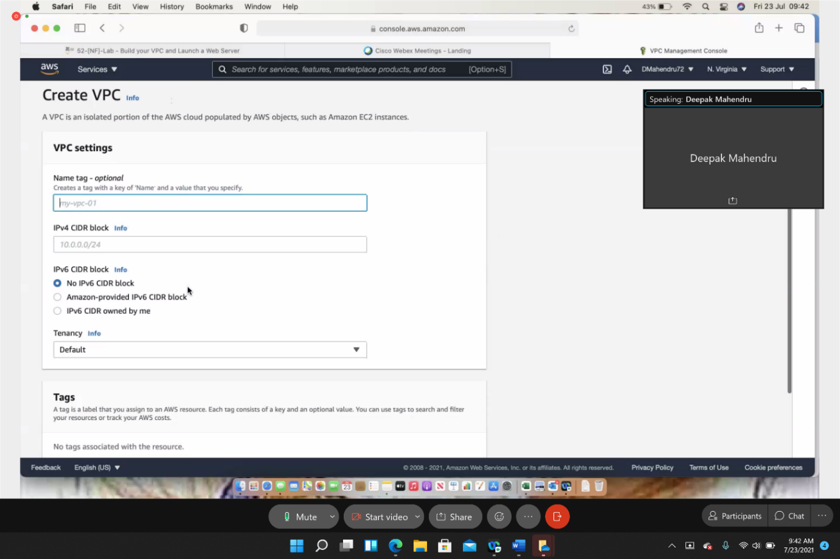

**Creating Subnets (2 private and 2 public in 2 availability zones)**

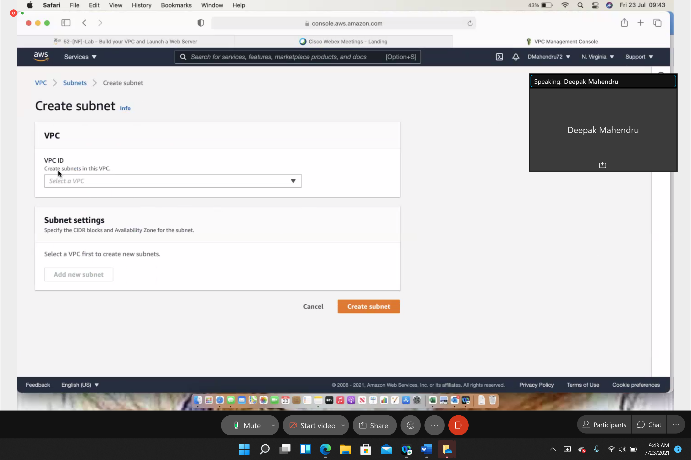

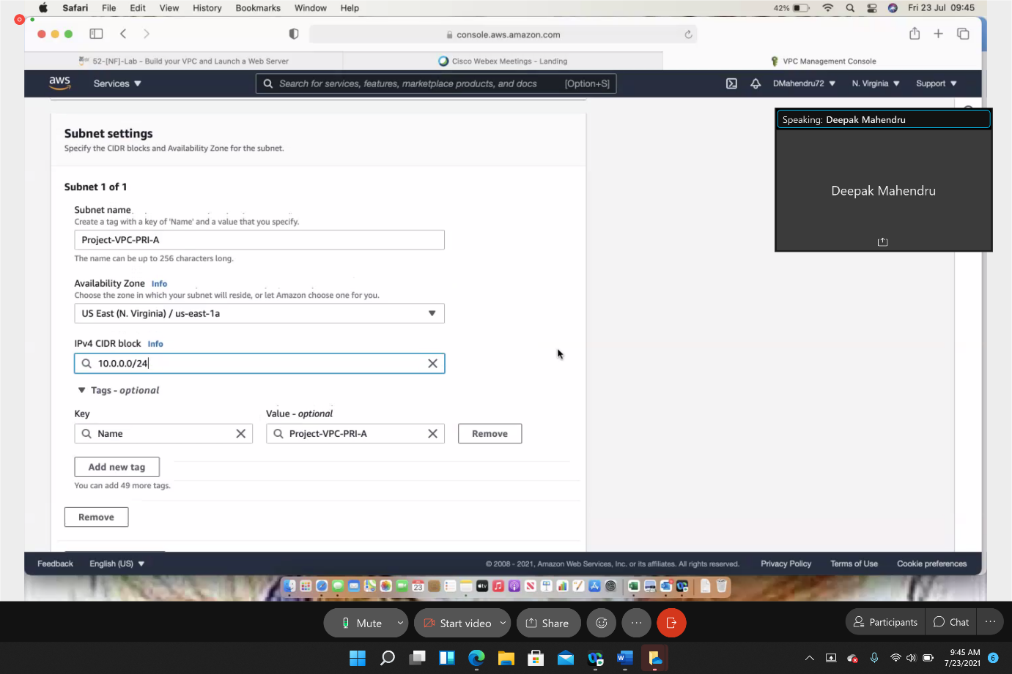

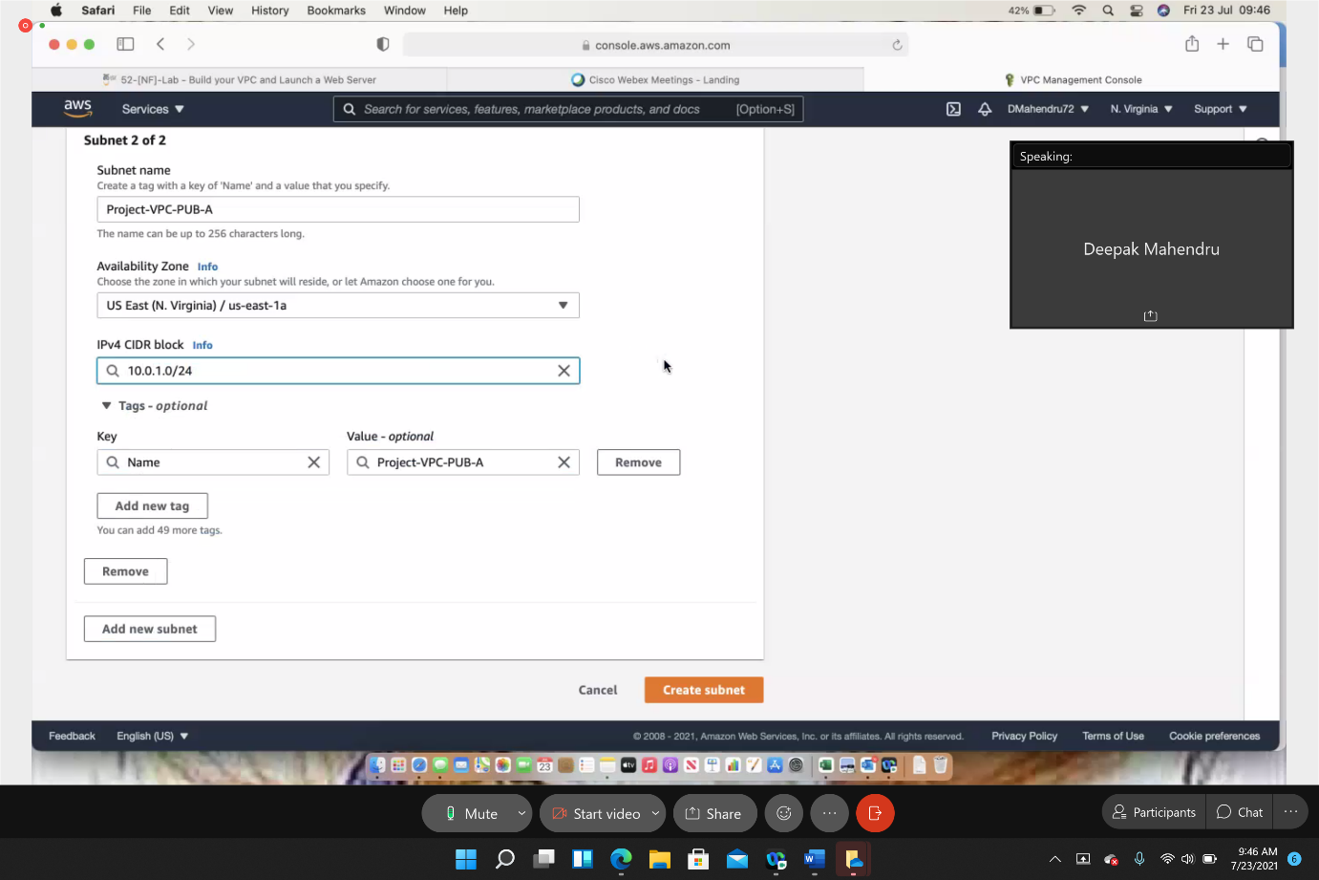

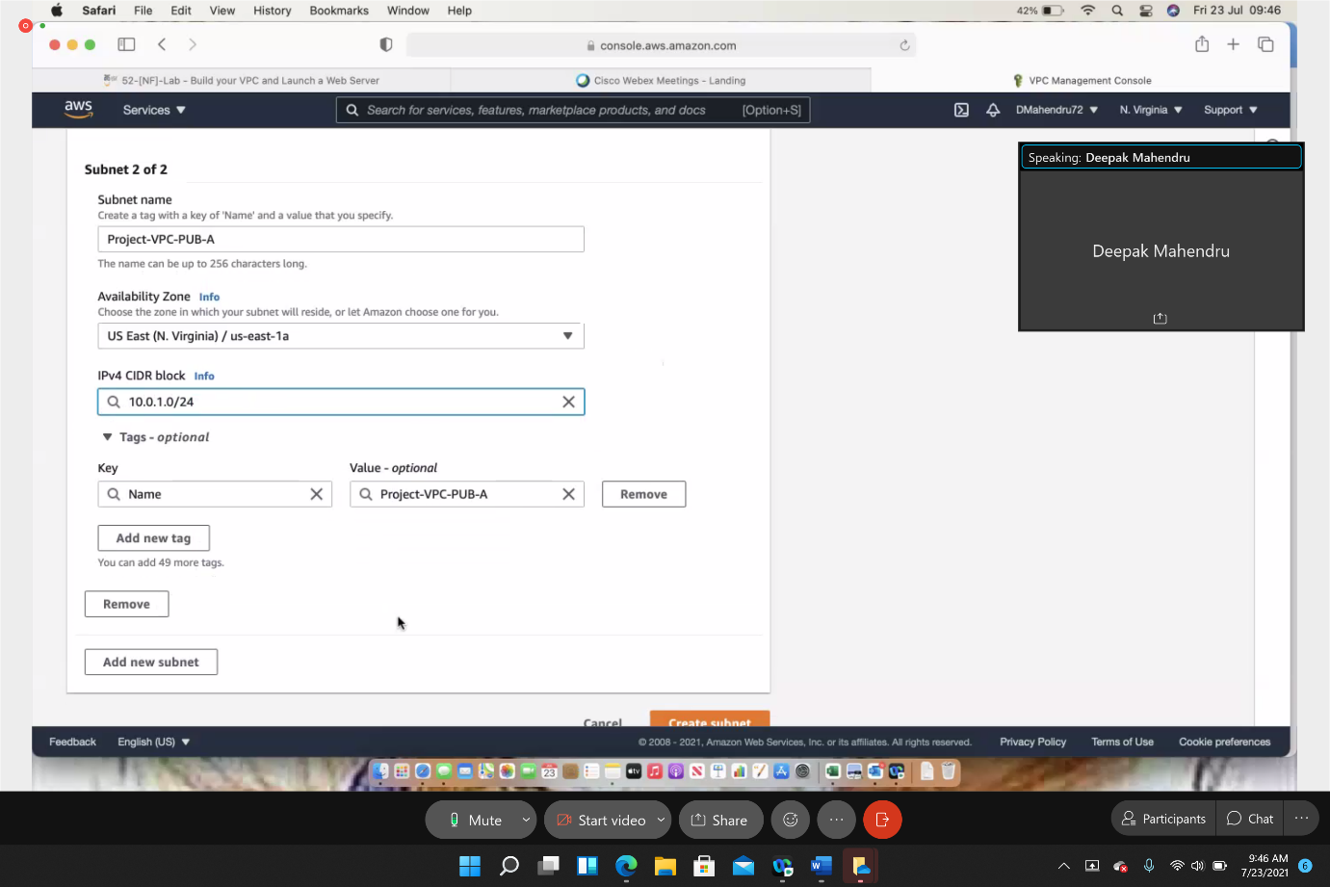

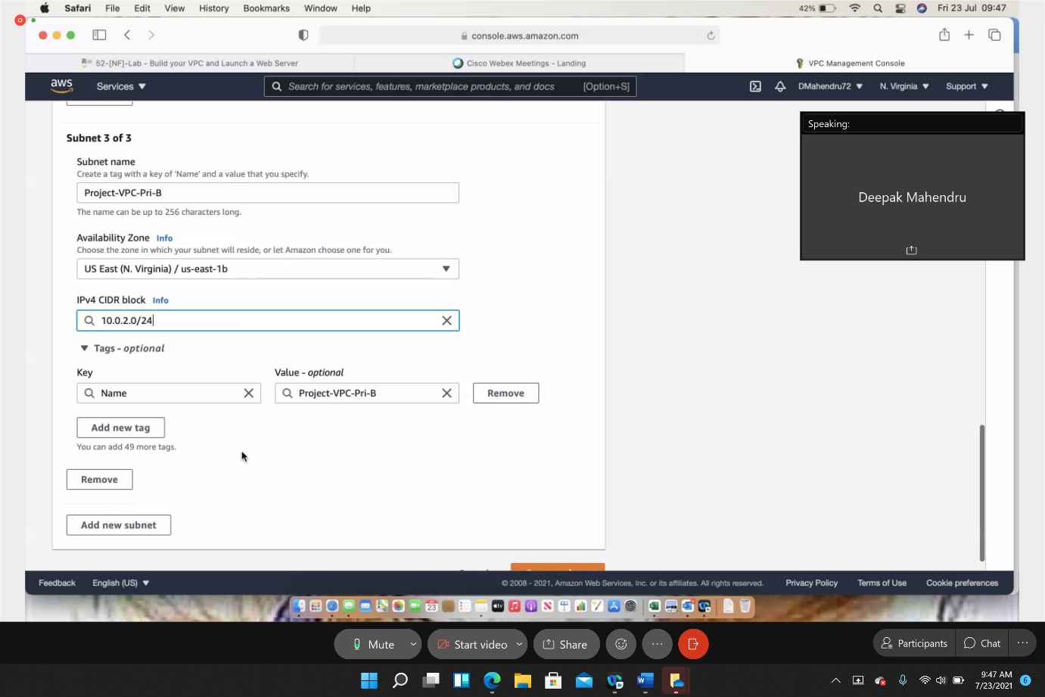

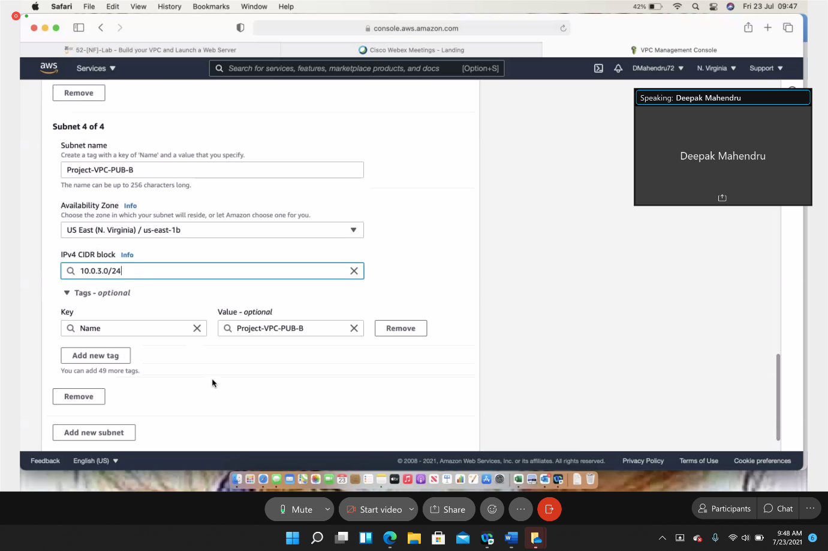

**Successfully created 4 subnets**

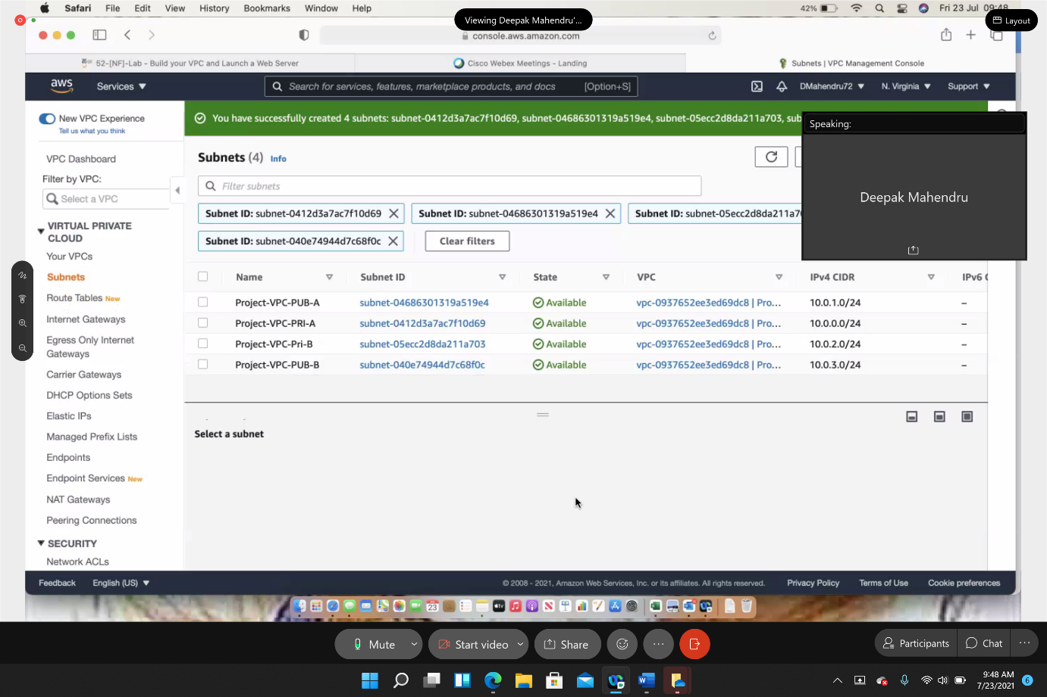

**Creating Route tables for subnets**

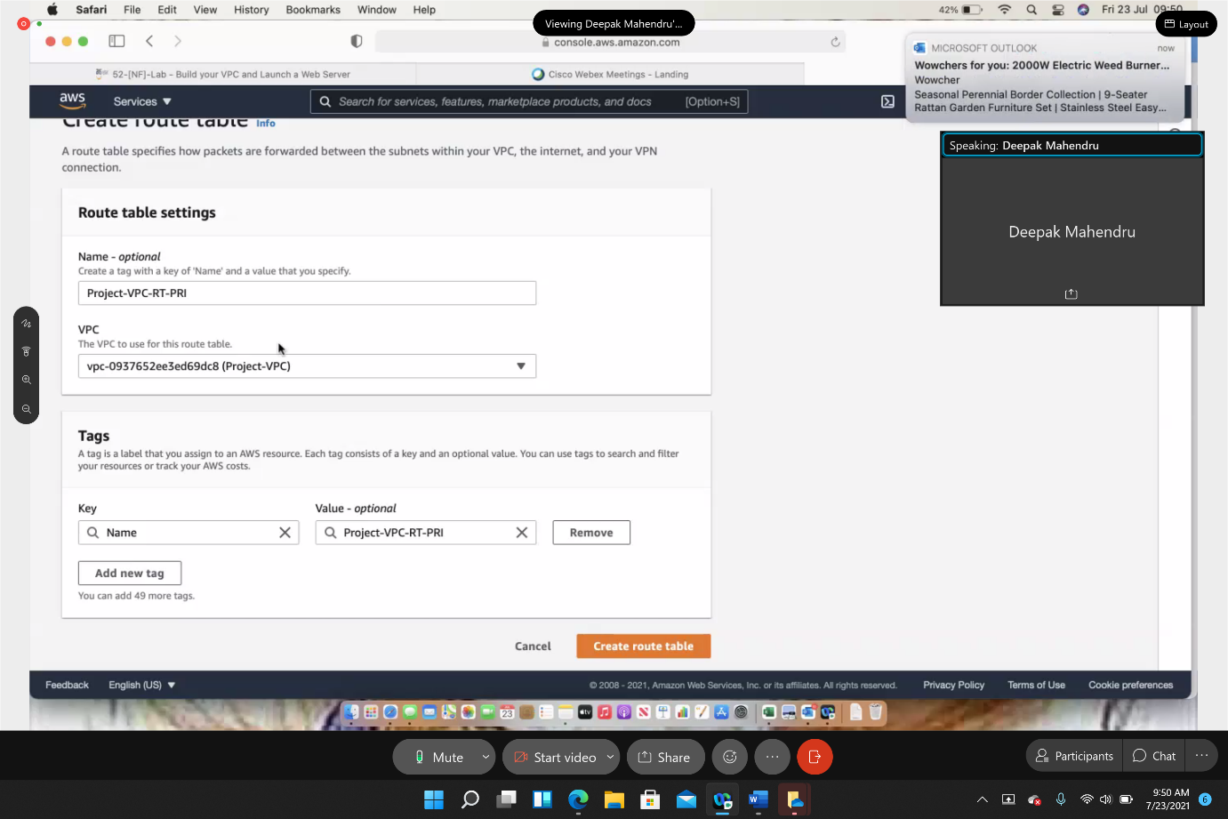

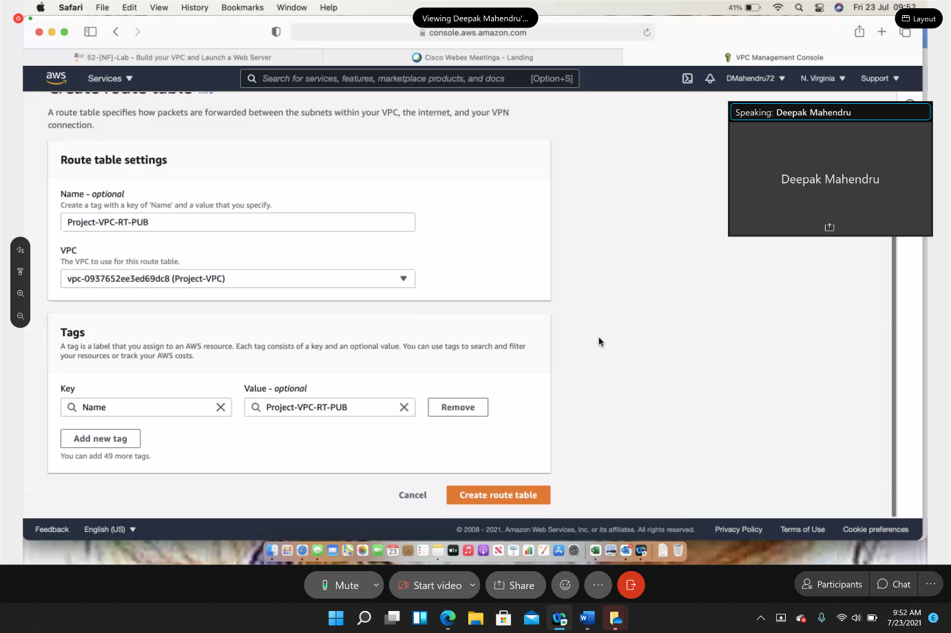

**Set Main route table**

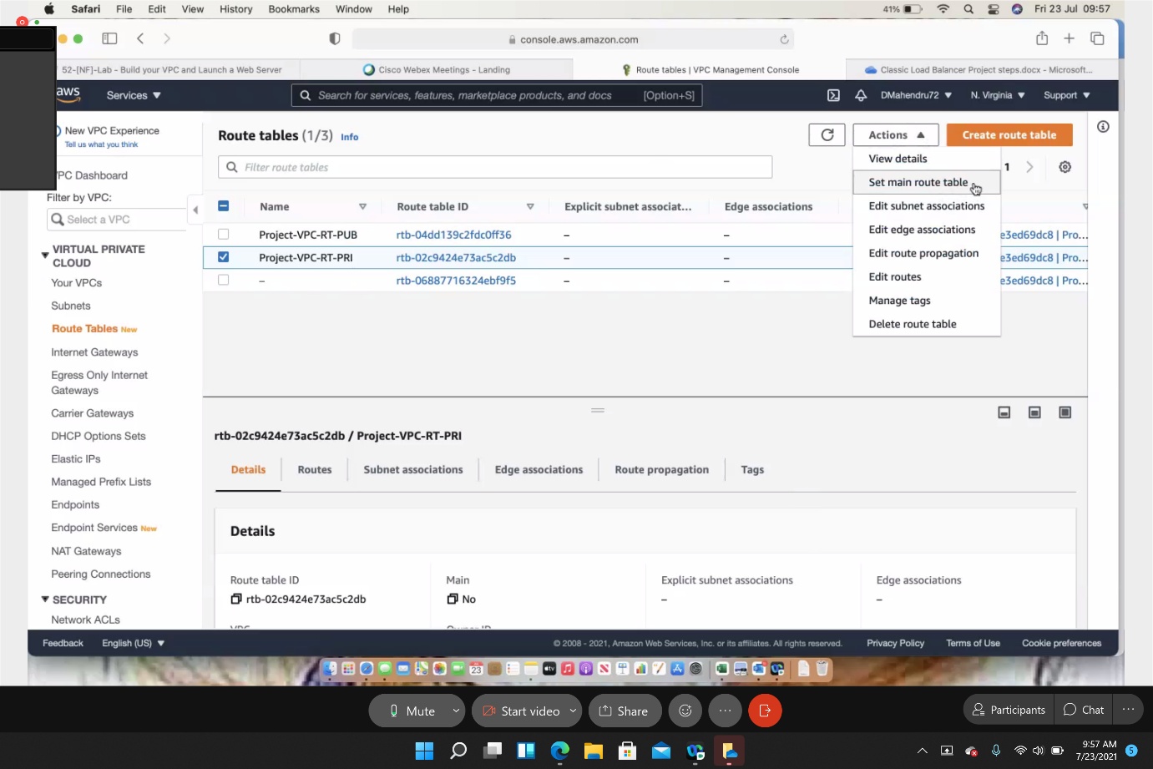

**Set Main route table**

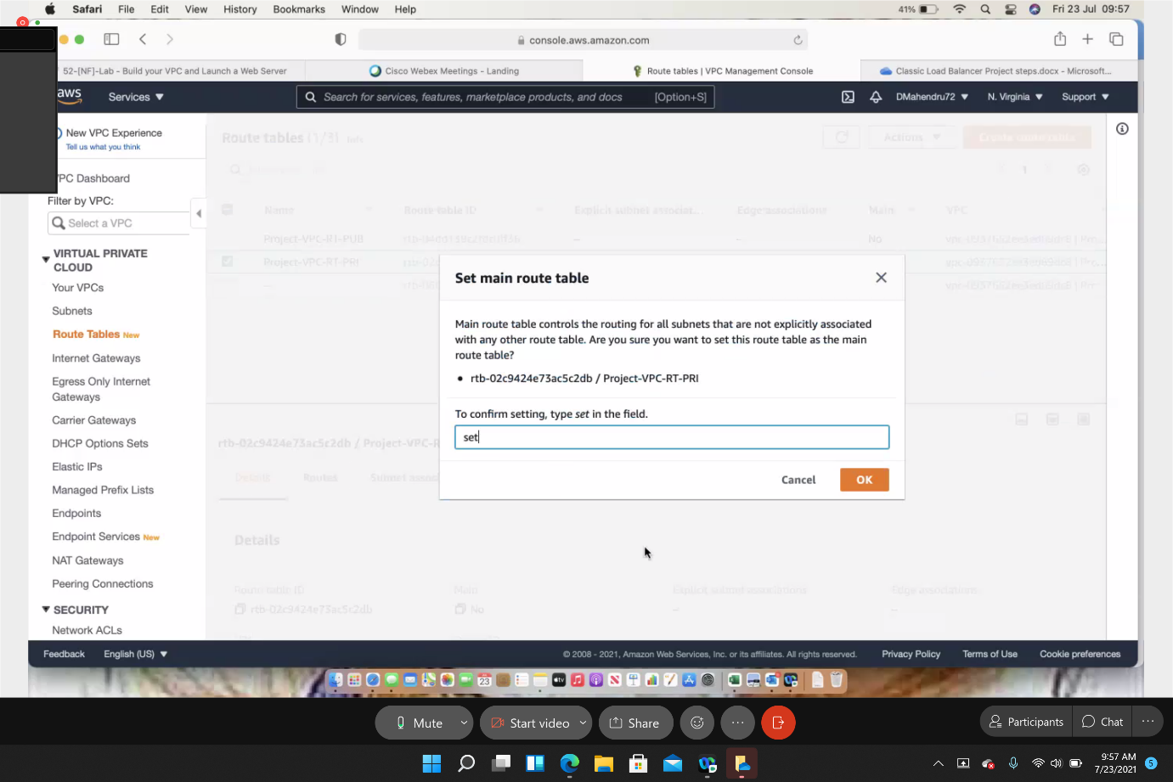

**Successfully set main route table**

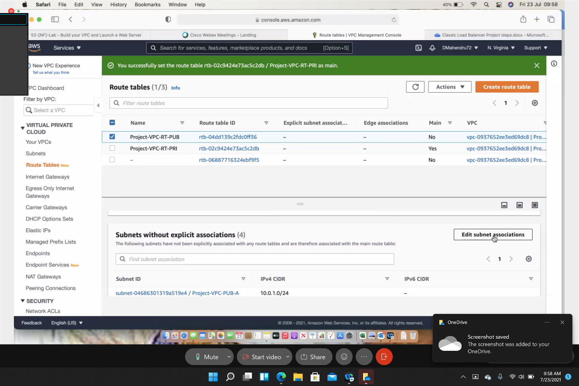

**Associating public and private subnets to different routing tables**

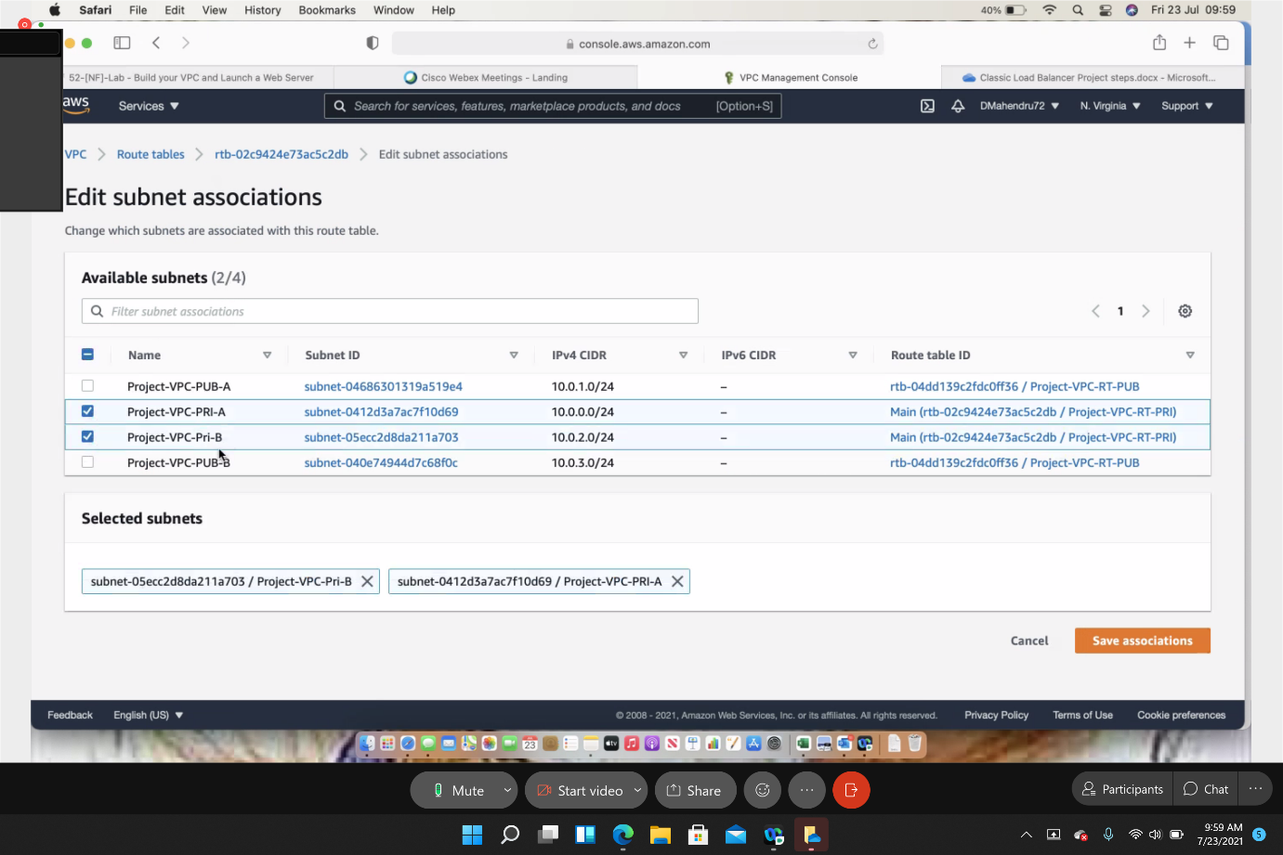

**Successfully updated public and private subnets**

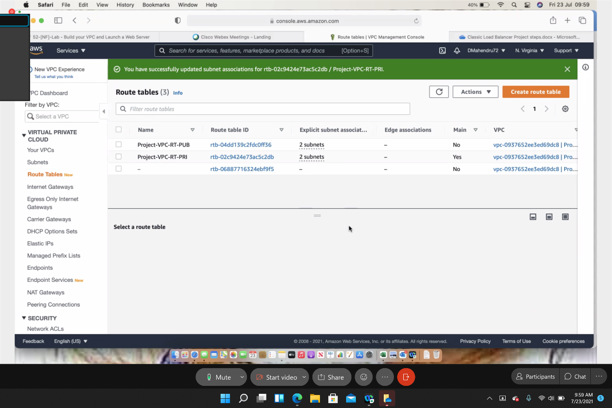

**Creating Internet gateway for public subnet access to internet**

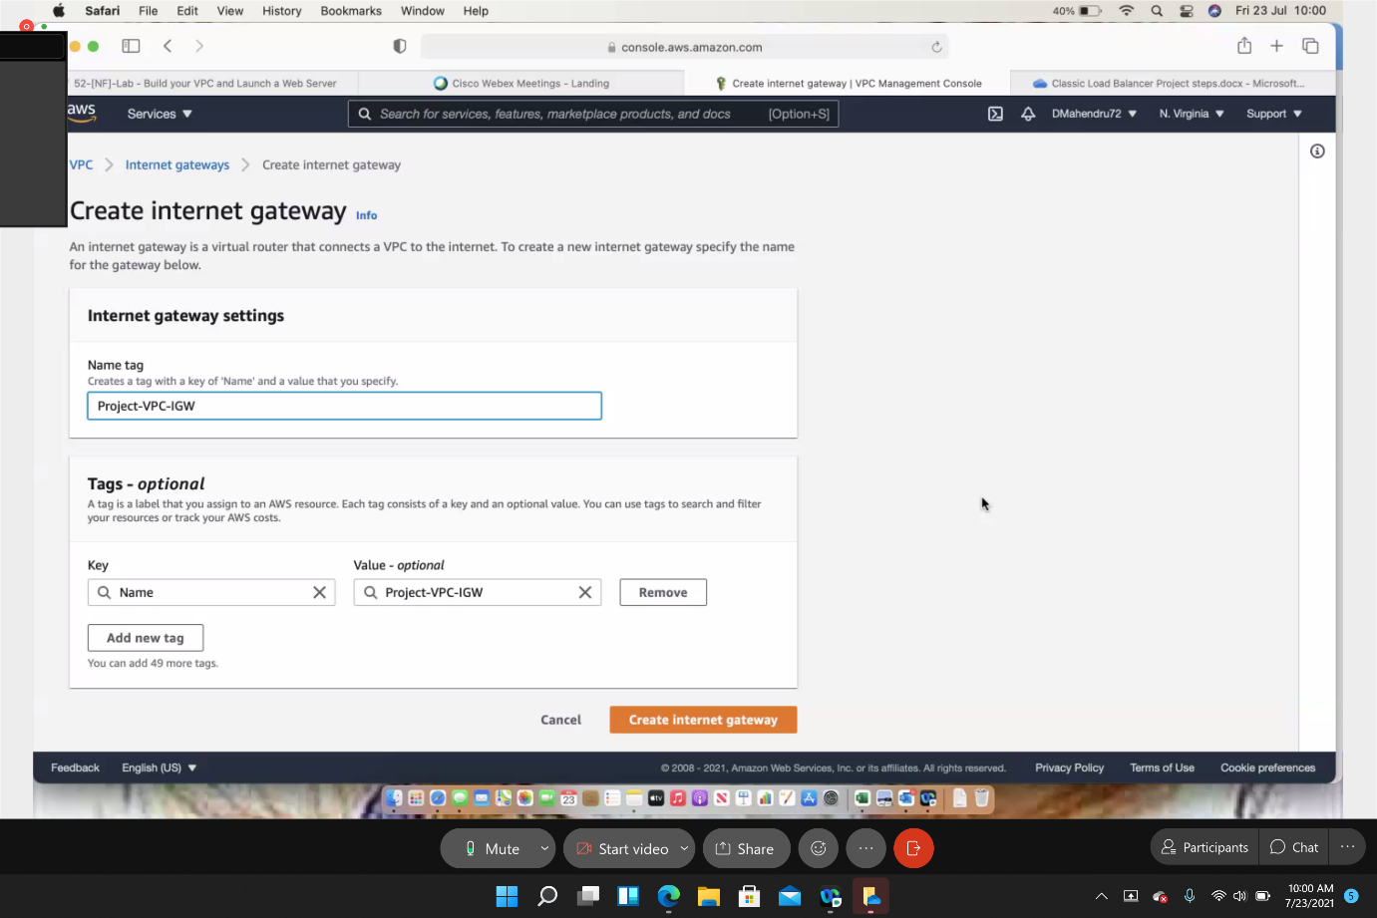

**Attach to VPC**

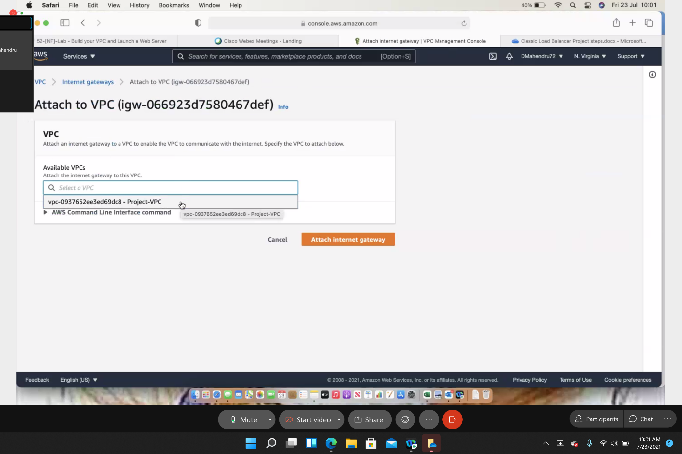

**Create NAT gateway for private subnet access to internet**

**Assigning public subnet to NAT gateway (allocate Elastic IP)**

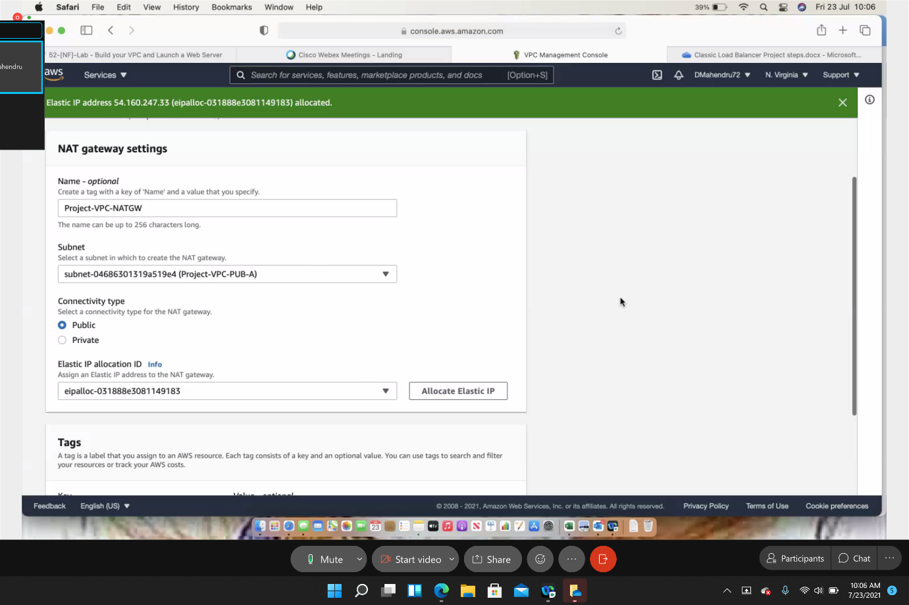

**Nat gateway successfully created**

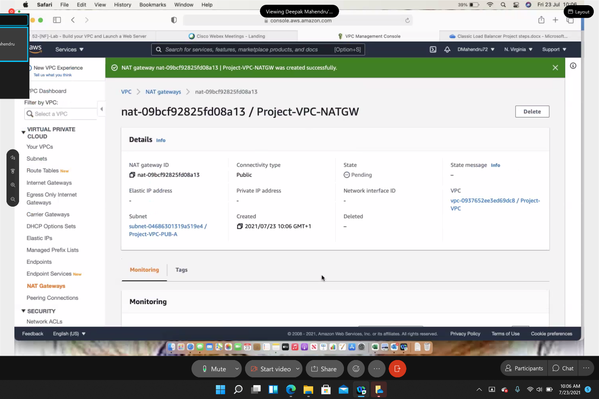

**Edit route tables (connect private to NAT gateway)**

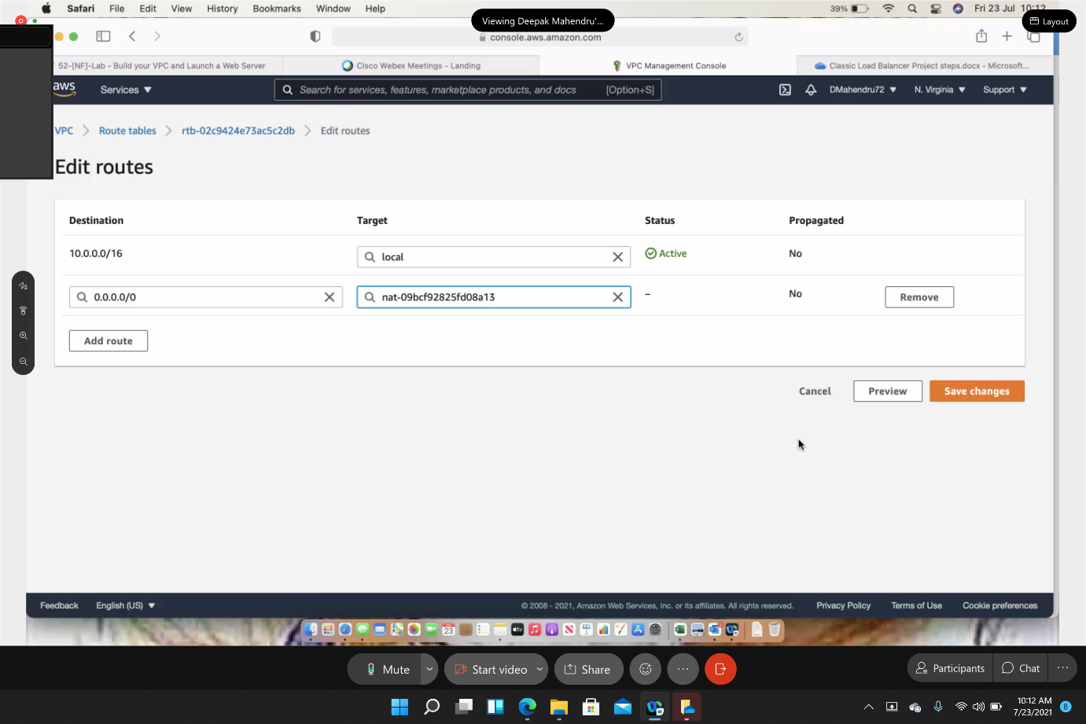

**Create EC2 instance (configure webserver 1 in private subnet A)**

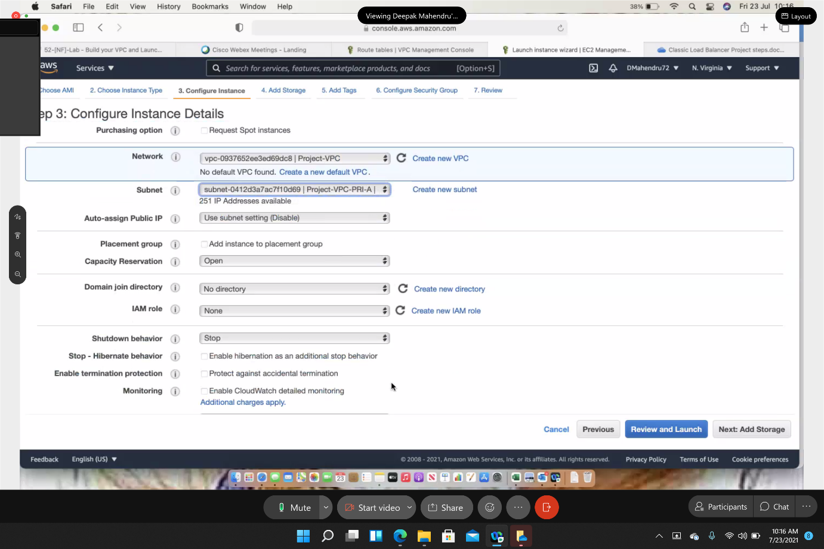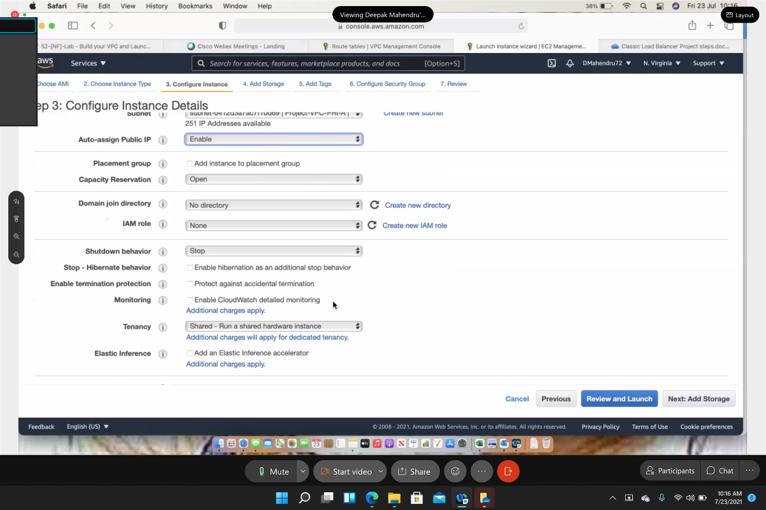

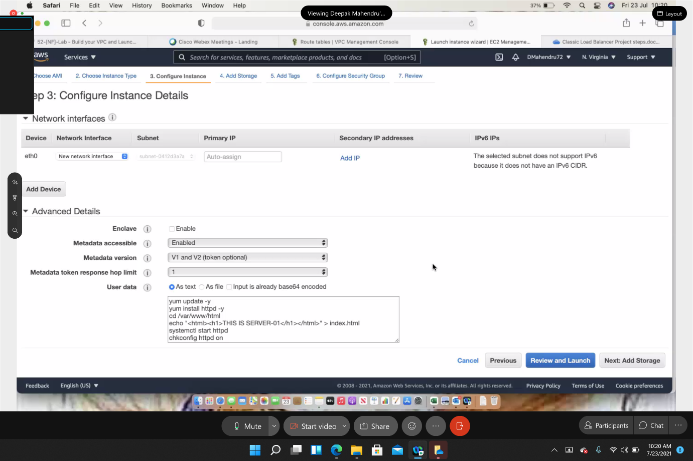

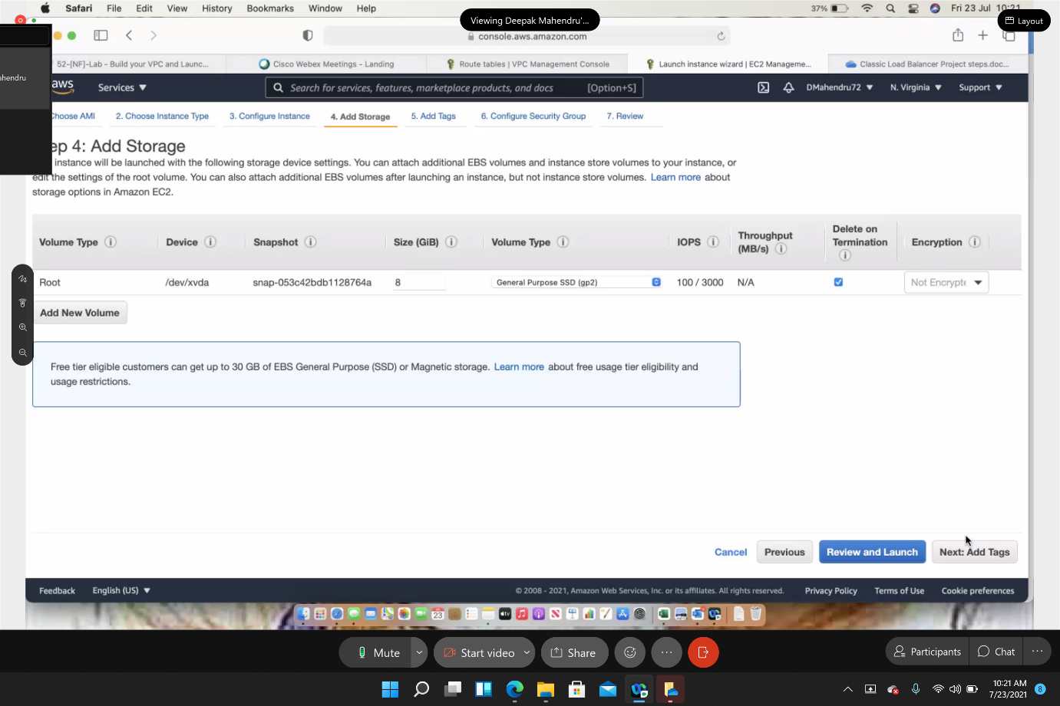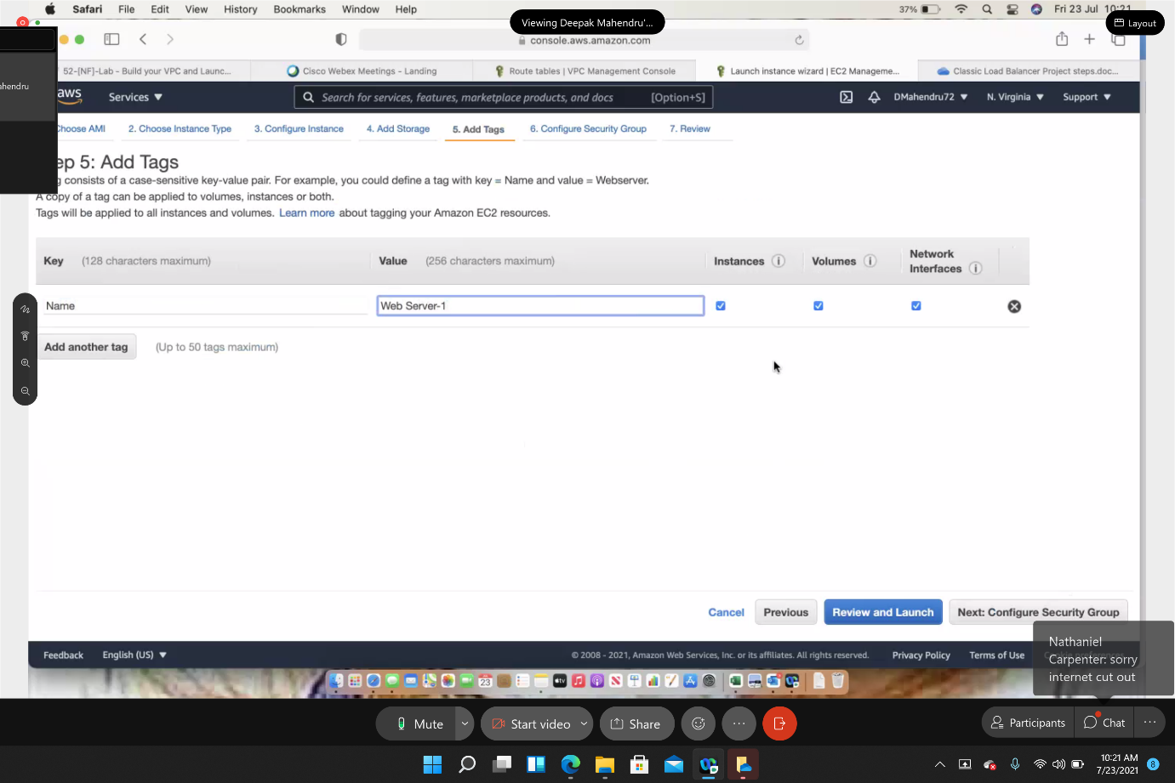

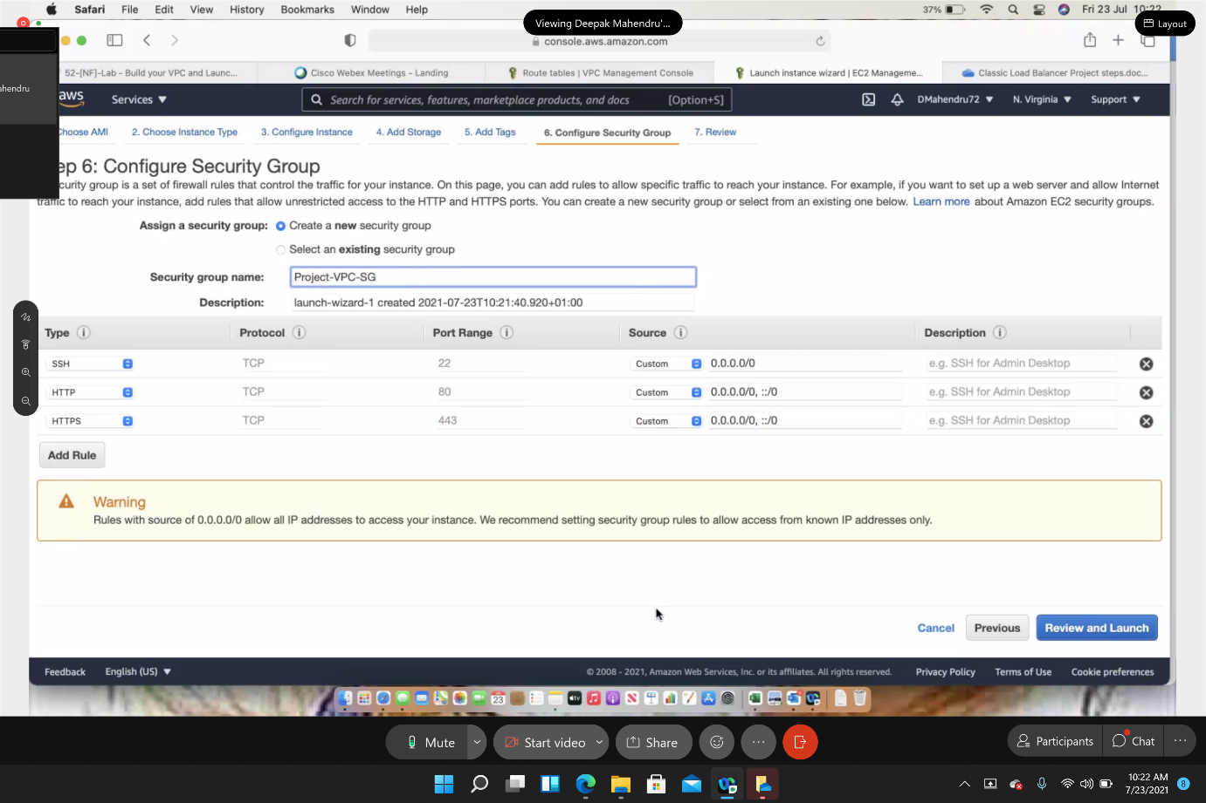

**Download Keypair for SSH (with putty on windows)**

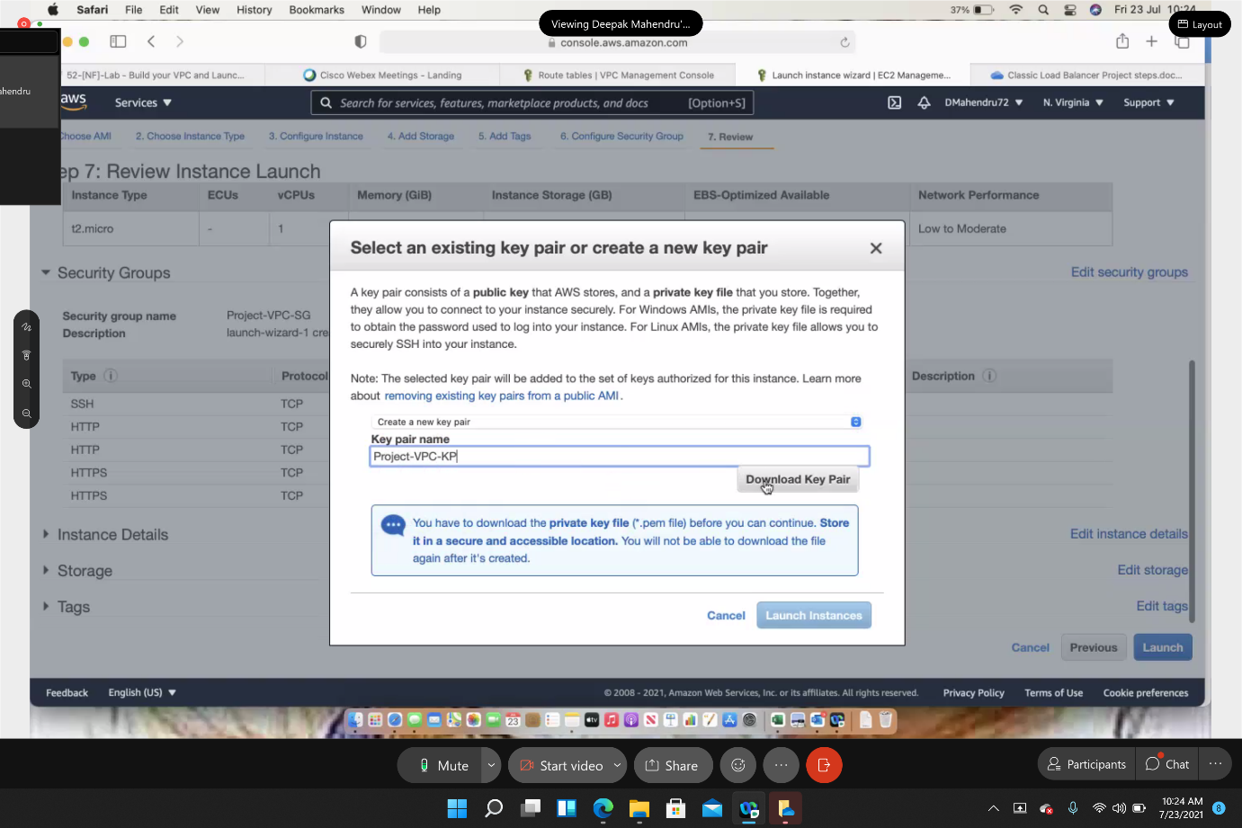

**Create EC2 instance (webserver 2 in private subnet B)**

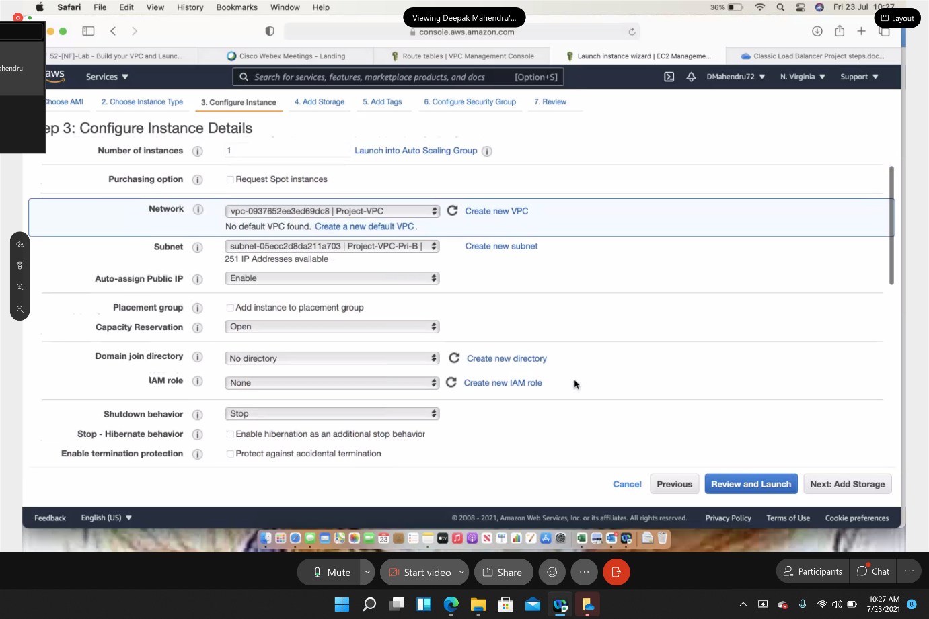

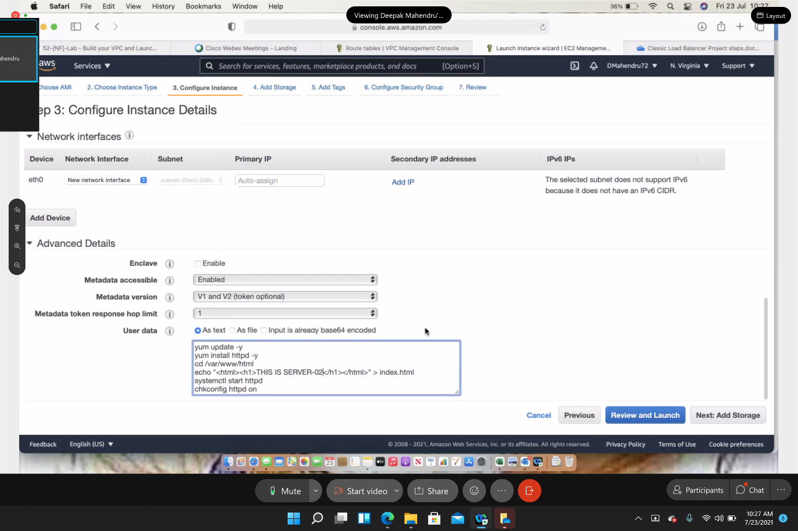

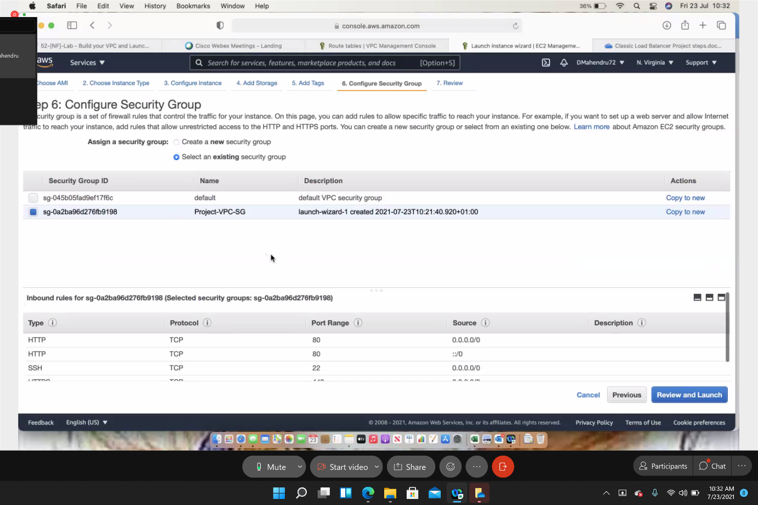

**Downloading the key pair for SSH**

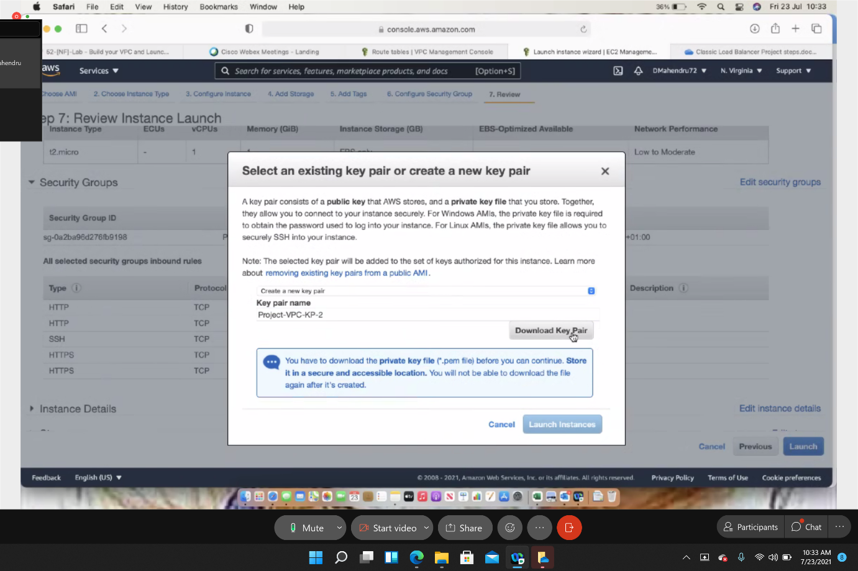

**Create EC2 (Bastion server in public subnet)**

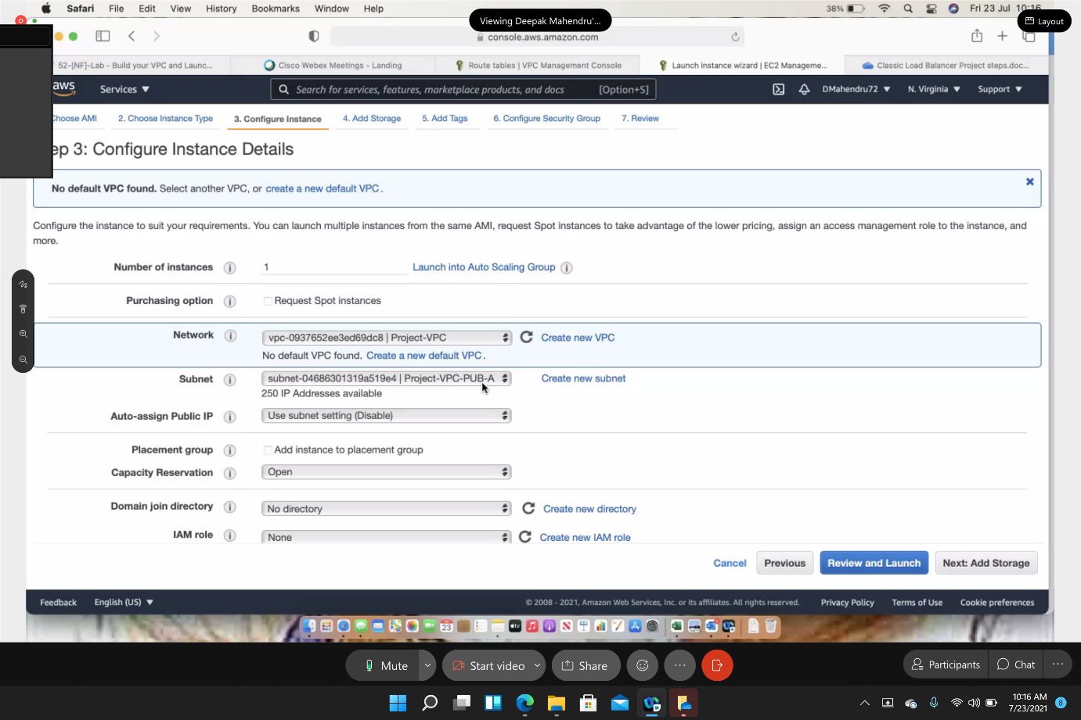

**Create Load Balancer**

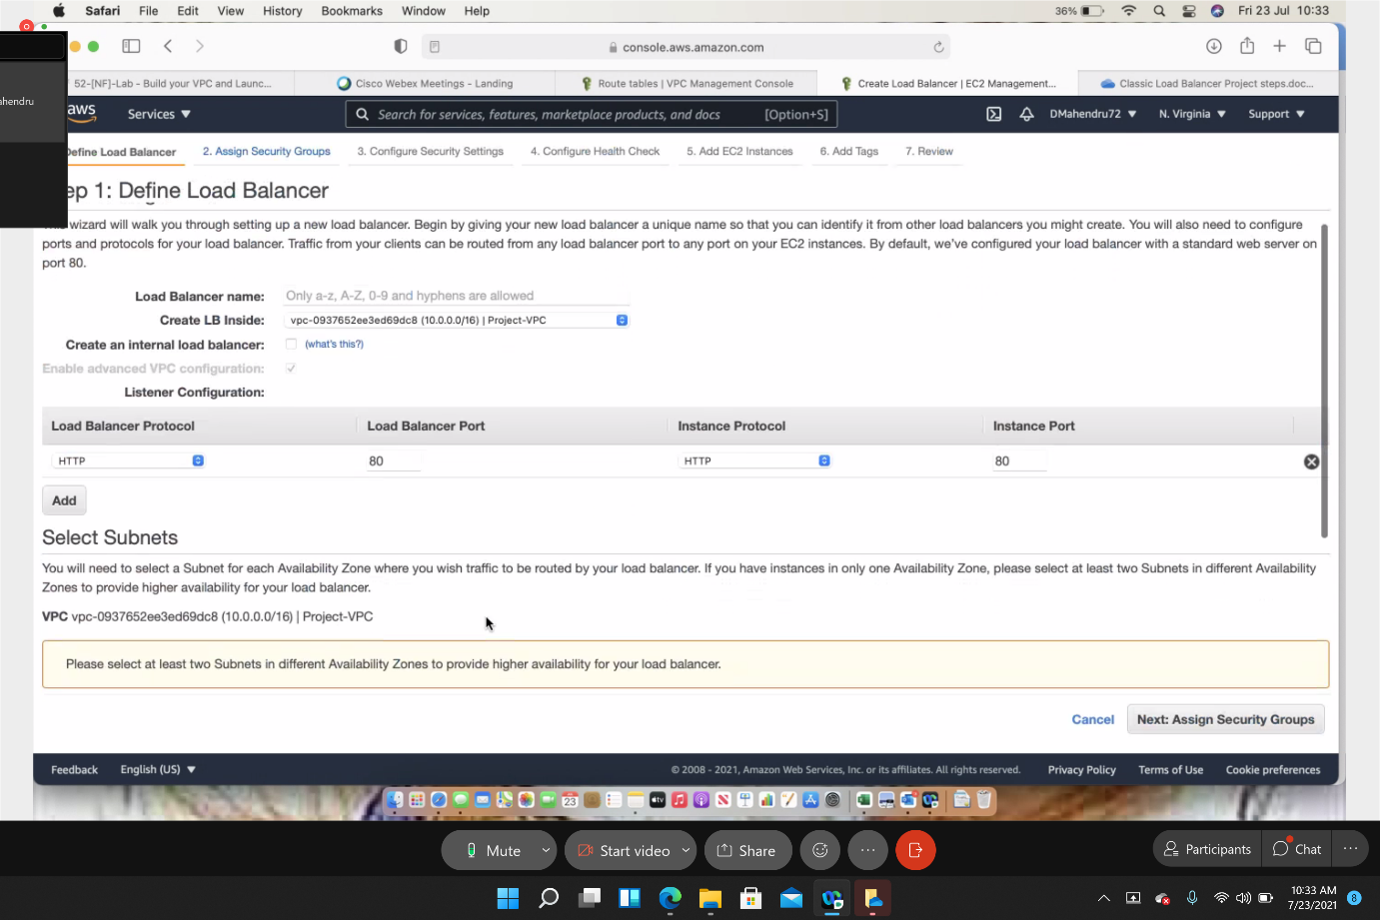

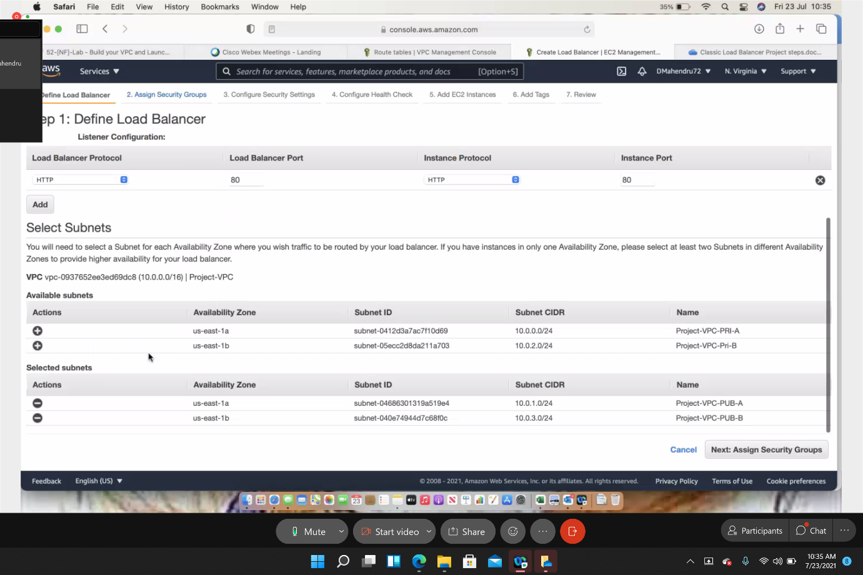

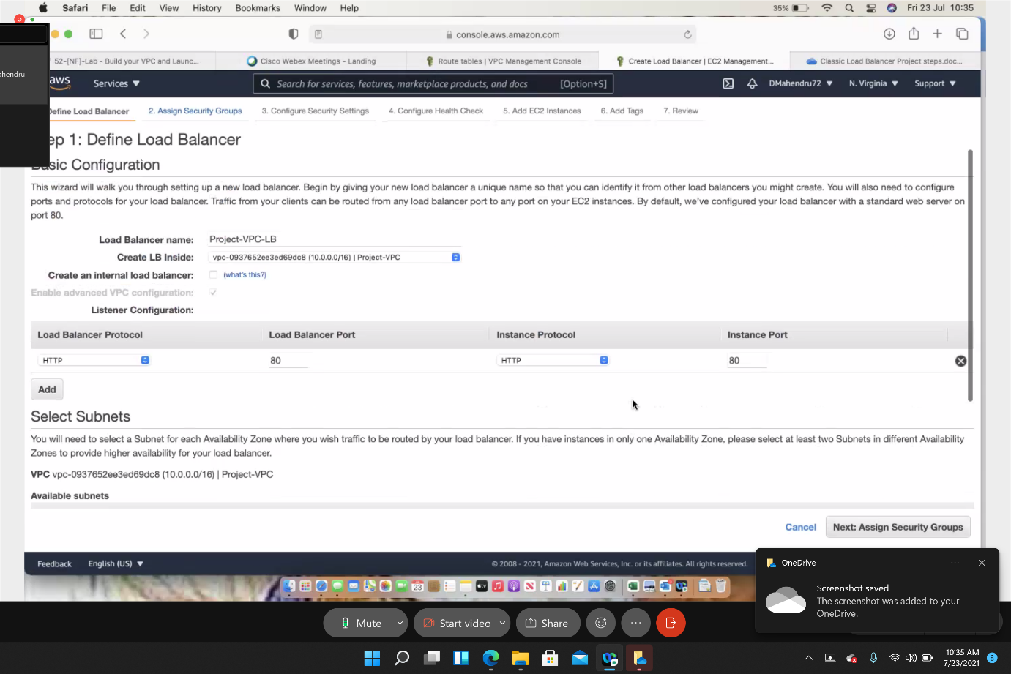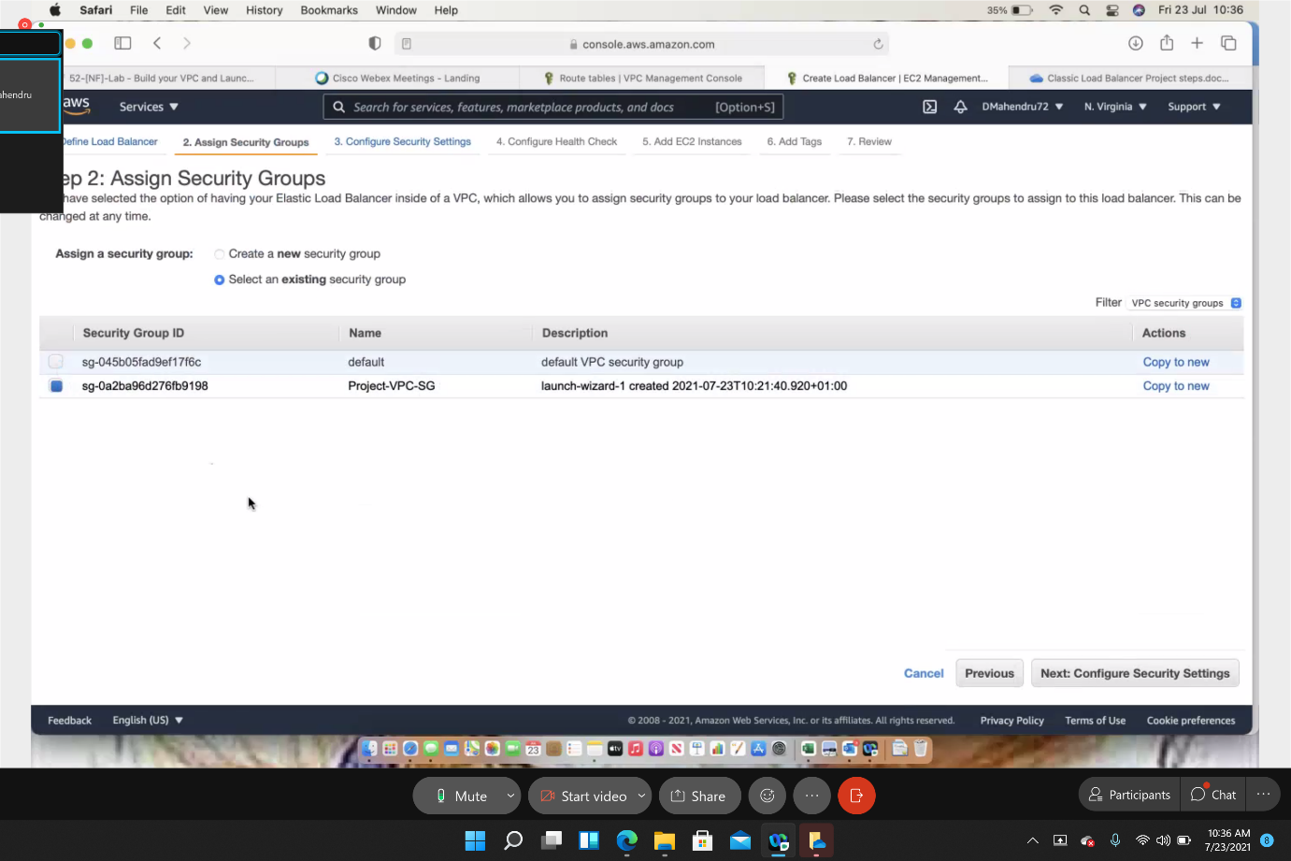

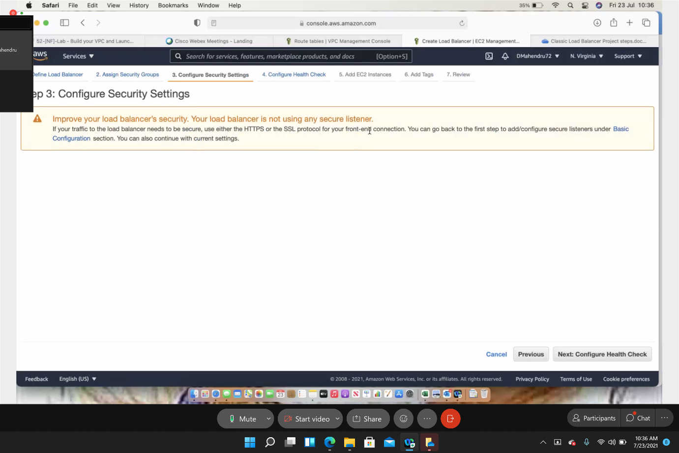

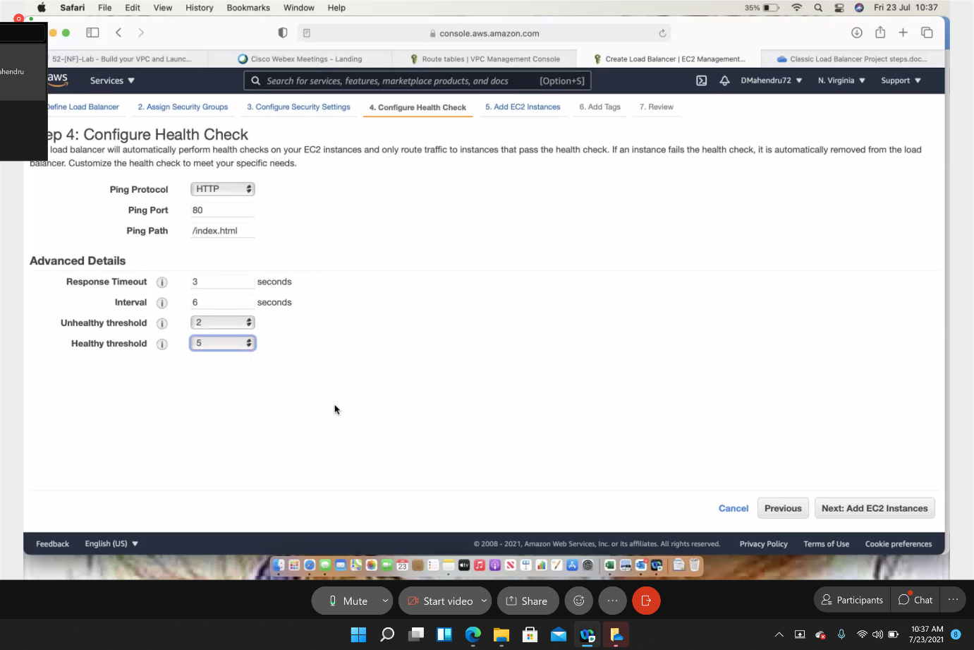

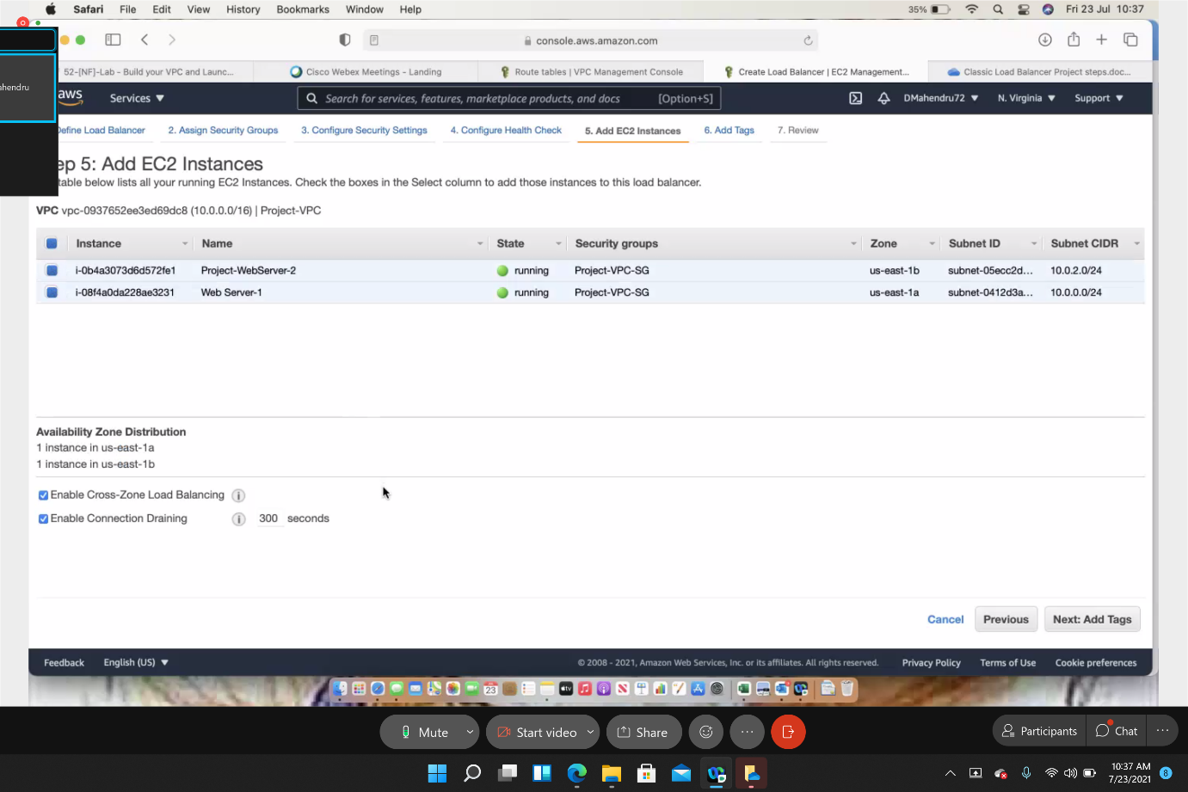

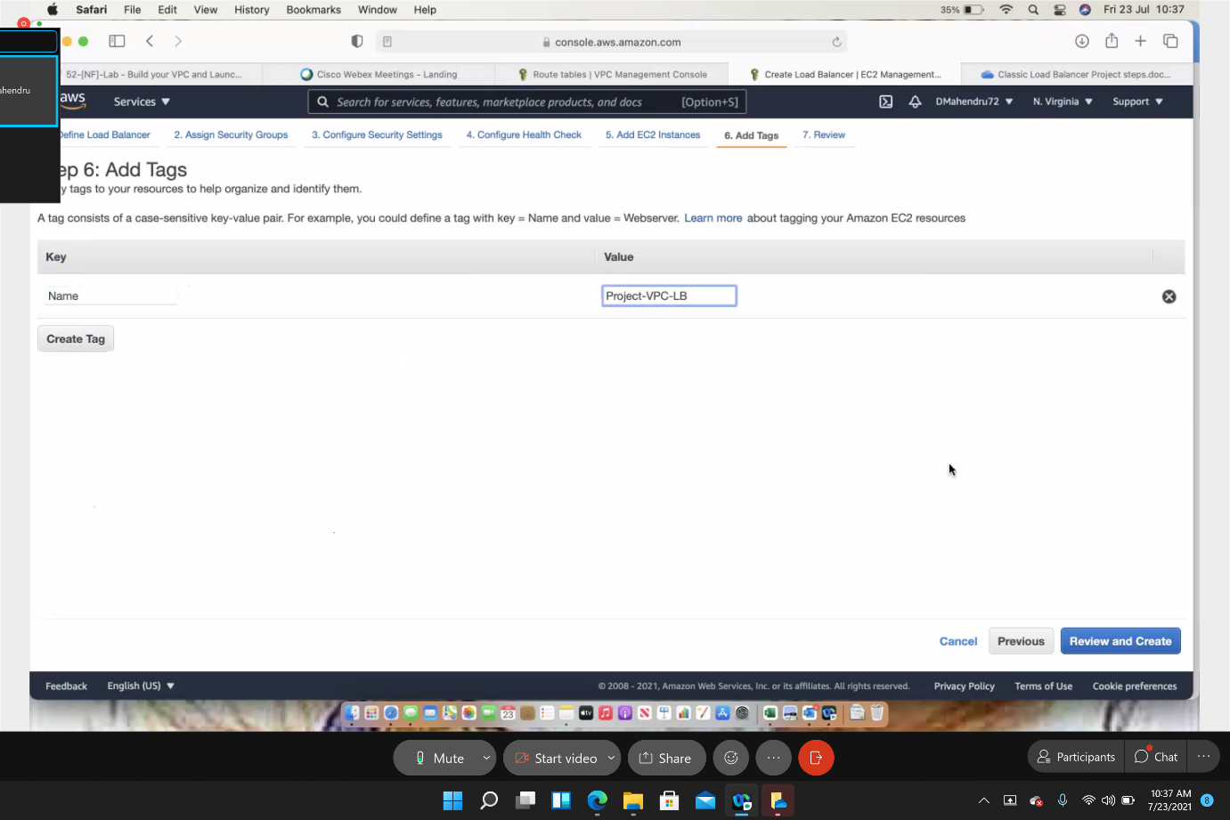

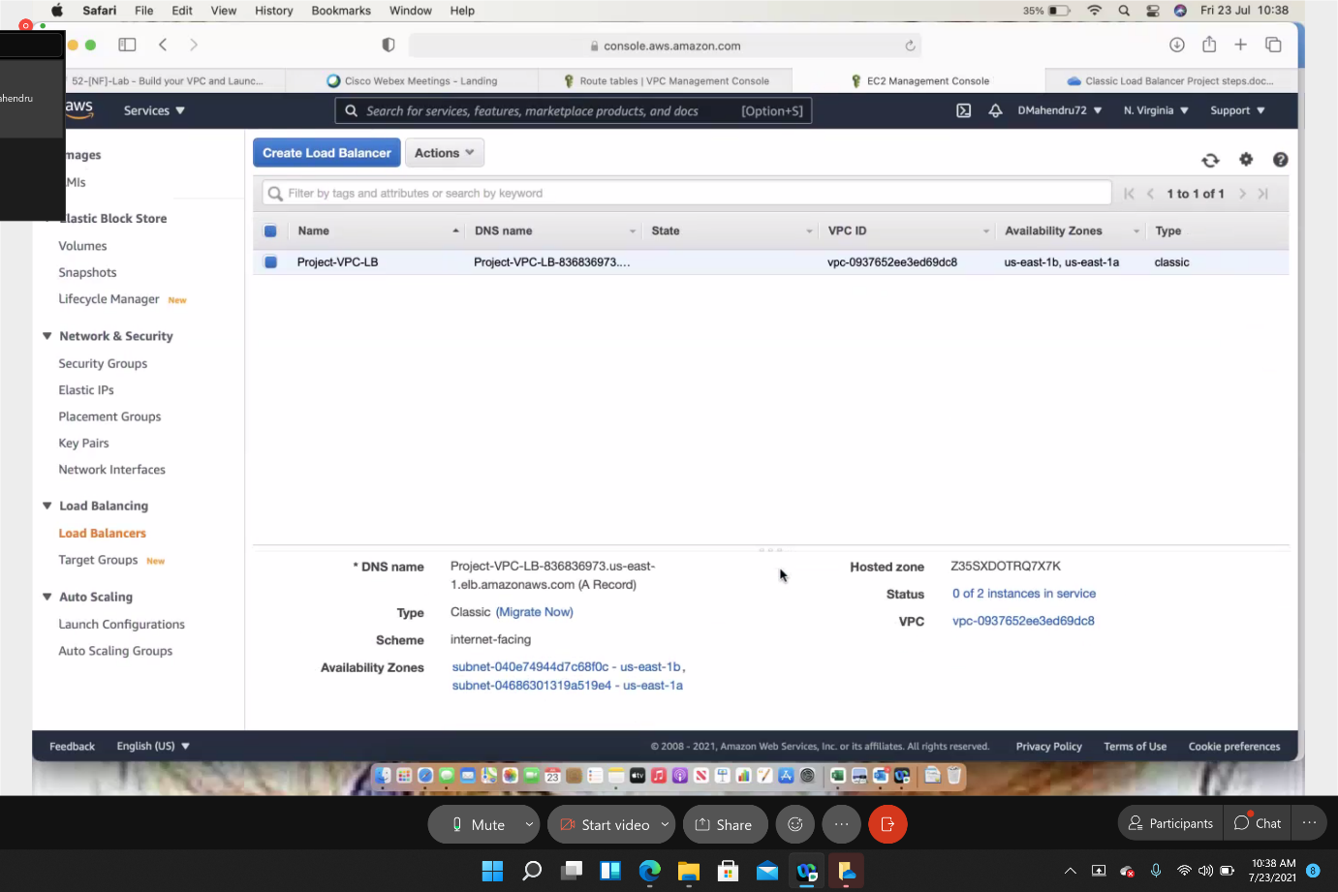

**Copy and paste DNS in web browser to test load balancer**

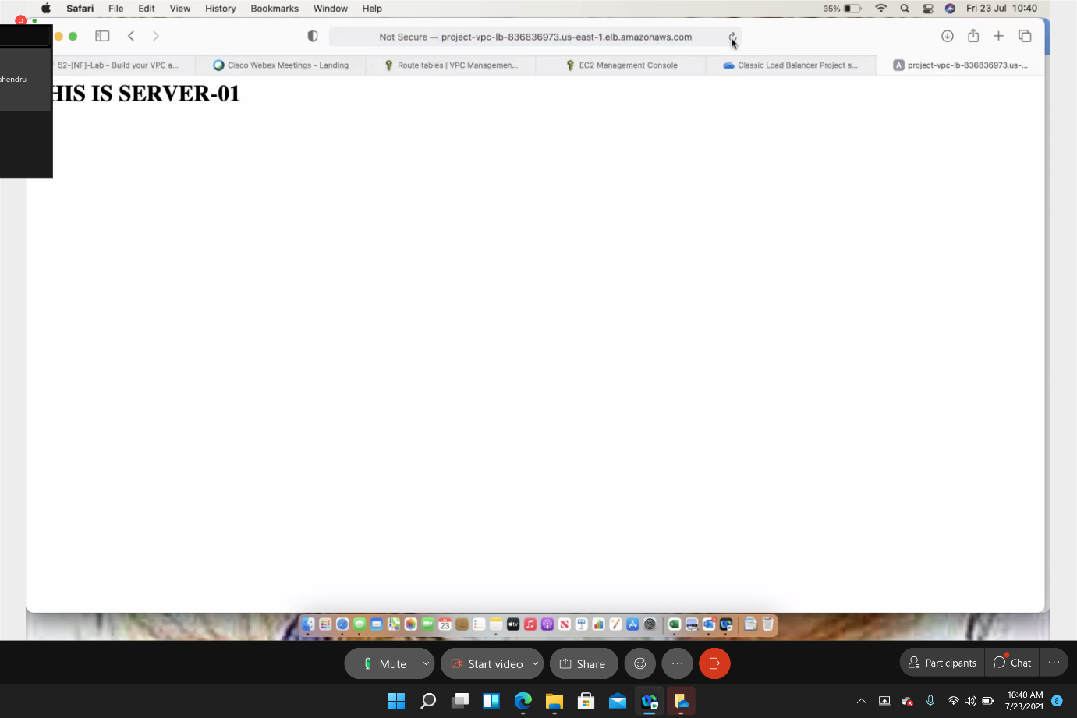

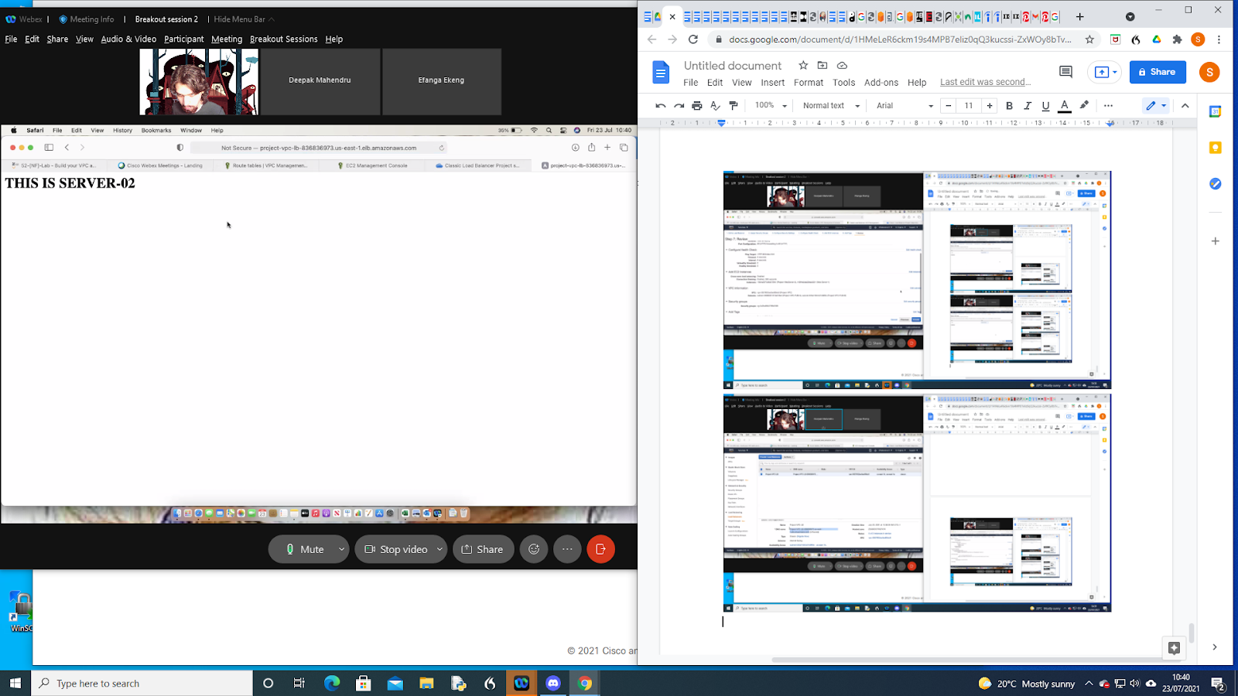

**Using SSH to Connect**

Open putty.exe

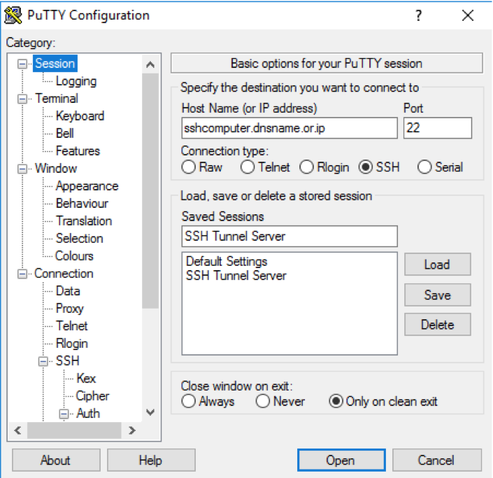

Configure PuTTY to not timeout:

Click Connection

Set Seconds between keepalives to 30

Configure PuTTY session:

Click Session

Host Name (or IP address): Paste the Public IPv4 value of the EC2 instance (Bastion Host)

PuTTy, in the Connection list, expand SSH

Click Auth (don't expand it)

Click Browse

Browse to and select the webserver.ppk file that was downloaded when instance was created

Login as ec2-user

Successful connection to instance.

From the Bastion Host you can now SSH to the web servers in your private subnets.